CMPE 110 – HOMEWORK 1

CHAPTER 1

Review Question 1
The following RL circuit is given:

In this circuit, the current, I, represents a constant current value. The current in the inductor, L, at t = 0sec is I/2 as shown in the schematic. At t = 0, the switch closes. Using the natural frequencies method

(a) Find the current through the inductor and plot it.
(b) Find the voltage across the inductor and plot it.

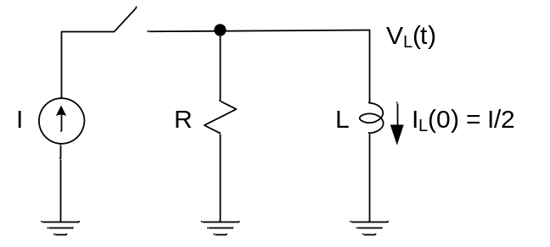

Review Question 2
The following RC circuit is given.
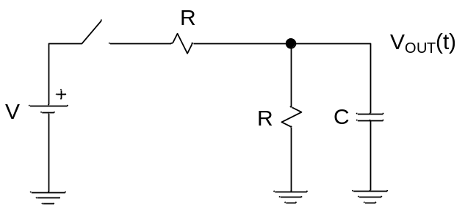

At t = 0, the switch closes. V is a constant voltage and V_{OUT}(0) = 0V.
Using natural frequencies method, find the output voltage, V_{OUT}(t) and plot it.

Now, change the location of the capacitor, C, as shown below. Assume the voltage across the capacitor is 0V at t = 0. How does V_{OUT}(t) change? Plot the waveform for V_{OUT}(t).
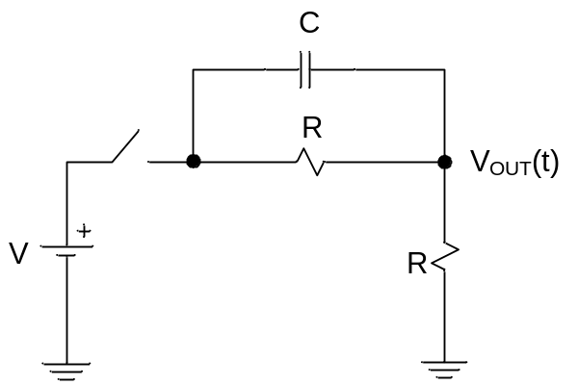

Review Question 4
The following circuits are given:

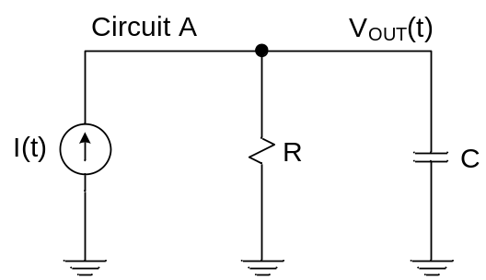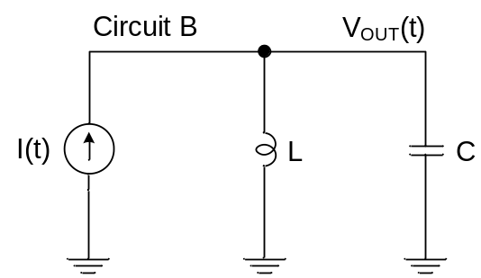

(a) Find the transfer functions, 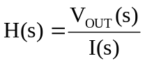, of circuits A and B.

(b) Draw the pole-zero diagrams of each circuit and find out their stability. From stability criteria, how does V_{OUT}(t) change with time?

Review Question 5
The following capacitive circuit is given.

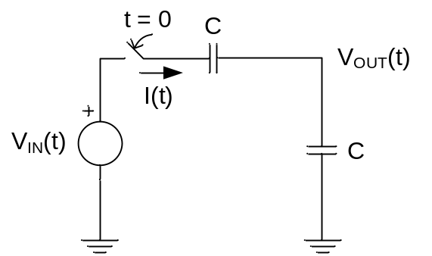

Initially, there is no charge on either capacitor and Vin(t) = V, a constant voltage. Solve I(t) and V_{OUT}(t) using time-domain analysis and plot them as a function of time.

Review Question 7
An LC circuit is given below:
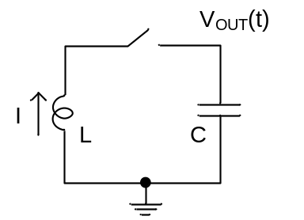

The initial current stored in the inductor is I in the direction indicated in the circuit schematic, and the voltage across the capacitor is 0V at t = 0sec before the switch is closed.
Find the expression for V_{OUT}(t) and draw its waveform using time-domain analysis.

Chapter 2

Review Question 1
The following rectifier circuit is given:
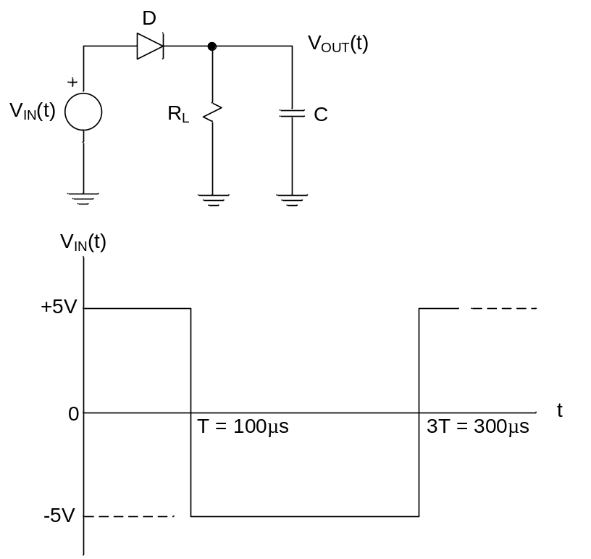

(a) If the diode turns on with a forward-biased voltage of 1V, C = 10uF, and R_{L} = 10Ω (load resistance), calculate the expression for V_{OUT}(t) and plot the output voltage.

(b) If R_{L} = 100Ω, what is the value of C if V_{OUT}(t) drops by 1V at 3T = 300µs from its initial value at T = 100µs?

Review Question 2
The following diode circuit is given:

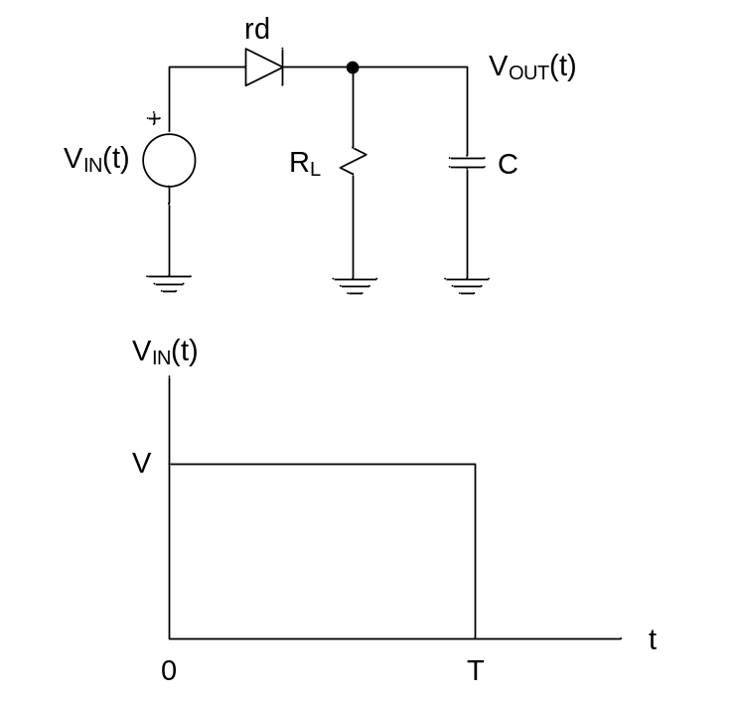

In this circuit, the equivalent resistance of the diode is rd when it turns on with a forward bias voltage of V_{F}, where V_{F} is much smaller compared to V for 0 < t < T.

Assuming V_{OUT}(0) = 0V, and the time constant of the circuit is much smaller than T, determine the output voltage, V_{OUT}(t), for 0 < t < T and t > T. Use Natural Frequencies Method given in Chapter 1 to obtain an equation for V_{OUT}(t). Plot the waveform.

Review Question 3
The following diode circuit is given:

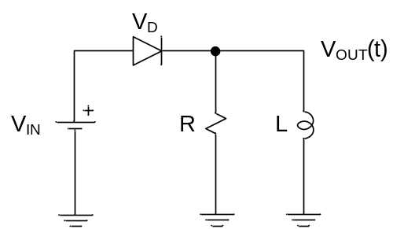

In this circuit above, when V_{IN} is reduced below V_{F}, the diode turns off. The inverse slope in the I-V characteristics below gives the diode internal resistance, r.
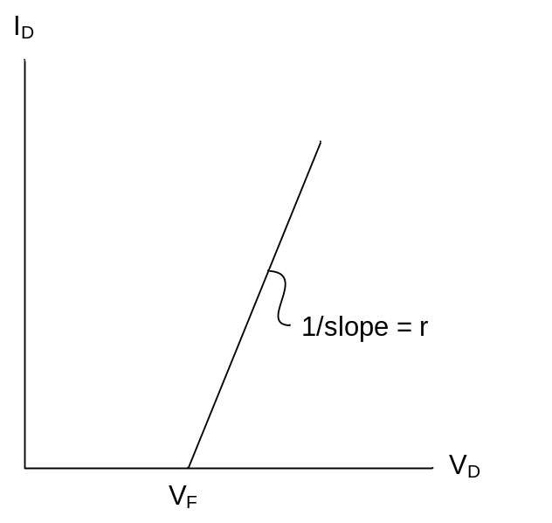

- Compute and plot the current through the inductor if the initial inductor current is 0A. Use Natural Frequencies Method to compute the result.

- Compute and plot the voltage across the output, V_{OUT}. Use Natural Frequencies Method to compute the result.

Review Question 4
The NPN bipolar transistor in the circuit below operates in the middle of active region. The transistor requires a collector current, I_{C} = 30mA, when the output of the circuit, V_{OUT}, is at 5V. The transistor develops V_{BE} = 0.7V in active region and maintains a current gain of 100, i.e. β (or h_{FE}) = I_{C} / I_{B} = 100.

Use the output I-V curve below to compute R_{B} and R_{C} that satisfies the proper transistor operation.

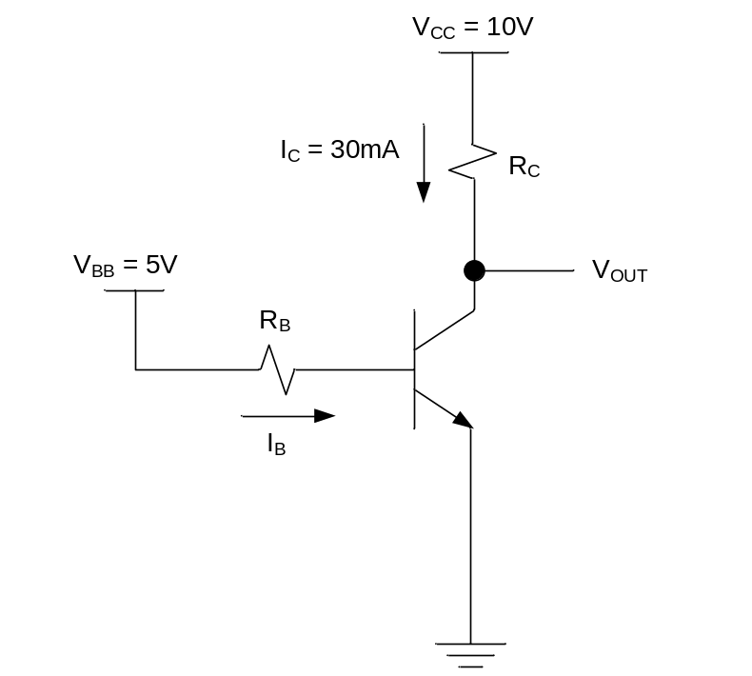

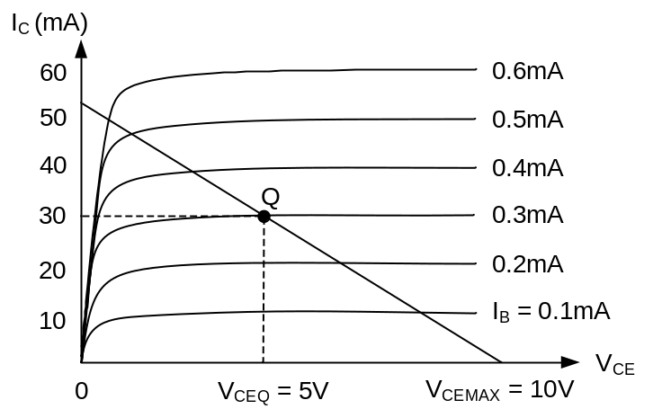

Review Question 5
The same NPN bipolar transistor in question 4 is used to operate in the saturation region where it develops V_{BESAT} = 0.8V and V_{CESAT} = 0.2V, and produces a base current, I_{BSAT}, about 10 times higher that its active region value, I_{BACT}.

If the transistor requires a collector current, I_{CSAT} = 30mA, to operate in saturation region, the load line in question 4 needs to be rotated counter-clockwise as shown in the I-V characteristics below. This rotation forms a new quiescent point, Q_{S}.
Find R_{B} and R_{C} to satisfy the proper transistor operation.

